|  |  |
| --- | --- |
|  | **DEPARTMENT OF COMPUTER ENGINEERING** |

Experiment No. 03

|  |  |
| --- | --- |
| Semester | B.E. Semester VIII – Computer Engineering |
| Subject | Distributed Computing Lab |
| Subject Professor In-charge | Dr. Umesh Kulkarni |
| Assisting Professor | Prof. Prakash Parmar |
| Academic Year | 2024-25 |

|  |  |
| --- | --- |
| Student Name | Deep Salunkhe |
| Roll Number | 21102A0014 |

**Title:** Design a Distributed Application for remote computation

**Explanation:  
  
1. Introduction**

In a distributed computing environment, multiple computers work together to achieve a common goal by sharing resources and computational tasks over a network. **Remote Method Invocation (RMI)** in Java enables a Java program to invoke methods on a remote object located on another machine, facilitating distributed applications.

This lab focuses on implementing a **distributed remote computation system** using **Java RMI**, where a client requests computations from a remote server.

**2. Objectives**

* To understand the **concept of Remote Procedure Call (RPC) / Remote Method Invocation (RMI)**.
* To implement **a remote computation service** that allows clients to perform computations remotely.
* To explore **how Java RMI handles object serialization, remote interfaces, and distributed computing**.

**3. Remote Method Invocation (RMI)**

**3.1 What is Java RMI?**

Java RMI is a **Java API that enables communication between Java objects in different JVMs (Java Virtual Machines)**, allowing method calls across network boundaries as if they were local method calls.

**3.2 Components of Java RMI**

Java RMI consists of the following components:

1. **Remote Interface**
   * Defines the methods that the client can invoke remotely.
   * Implemented by the server.
2. **Remote Object (Implementation Class)**
   * Implements the remote interface and contains the business logic.
   * Must extend UnicastRemoteObject to be accessible remotely.
3. **RMI Registry**
   * A simple lookup service where remote objects are registered.
   * Clients query the registry to obtain a reference to a remote object.
4. **Client**
   * Connects to the RMI registry and invokes remote methods.
5. **Stub and Skeleton**
   * **Stub:** Client-side proxy for the remote object.
   * **Skeleton:** Server-side proxy that interacts with the stub (used in Java versions prior to Java 5).

**4. Working of Java RMI**

The Java RMI architecture follows these steps:

1. **Server creates a remote object** and binds it to the RMI registry.
2. **Client looks up the remote object** from the registry.
3. **Client calls a method on the stub** (local proxy for the remote object).
4. **Stub forwards the request** to the remote object via RMI runtime.
5. **Remote object executes the method** and returns the result.

**5. Implementation Steps**

**5.1 Define a Remote Interface**

The remote interface extends java.rmi.Remote and declares methods that can be invoked remotely.

**5.2 Implement the Remote Object**

The implementation class extends UnicastRemoteObject and implements the remote interface.

**5.3 Start the RMI Registry**

The **RMI Registry (rmiregistry)** acts as a lookup service where the remote object is registered.

**5.4 Bind the Remote Object**

The remote object is **bound to a name** in the RMI registry, making it accessible to clients.

**5.5 Implement the Client**

The client looks up the remote object and invokes the desired remote methods

**CODE:  
  
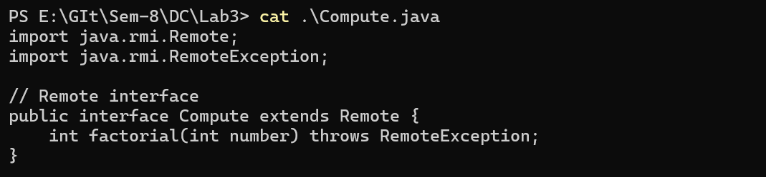**

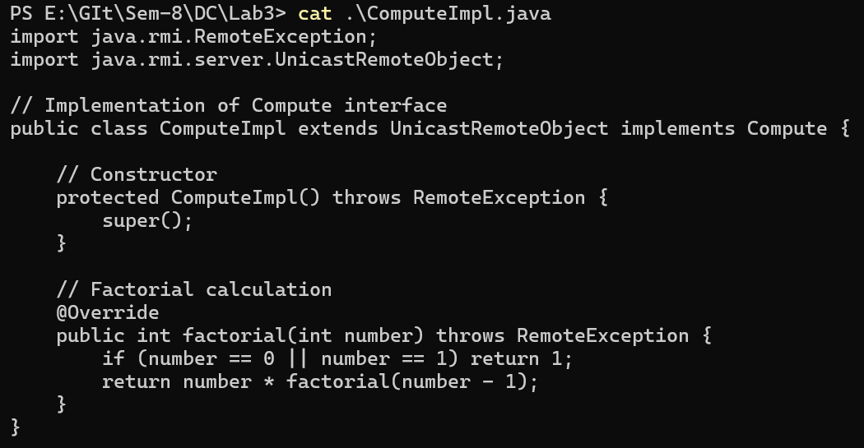

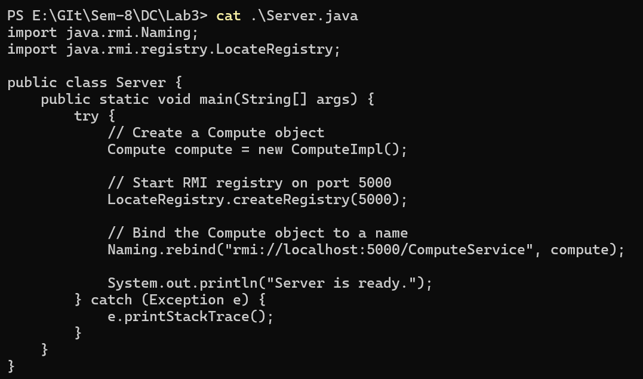

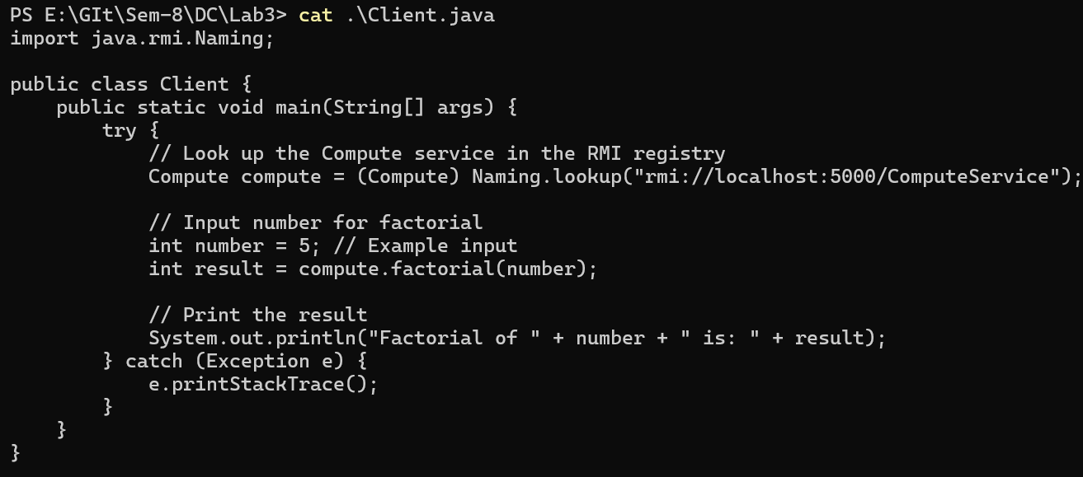

**Output:**

